**CS155 Miniproject 2 – Eva L. Scheller and Eric Han**

**Basic Visualizations**

Fig. 1 depicts the total number of ratings. Here we observe that the most common ratings are either 3 or 4 stars, while 1 or 2 stars are less common. This observations match with what we would have expected since people are generally most likely to give average/above average rating. Fig. 2 depicts the 10 most popular movies: Raiders of the Lost Arc, Independence Day, Air Force One, Toy Story, Scream, The English Patient, Liar Liar, Return of the Jedi, Fargo, and Contact. These appear to be movies that are either classics (e.g. The English Patient, Fargo) that have persisted through time, big Hollywood action movies (e.g. Air Force One, Independence Day), or part of a franchise (e.g. Indiana Jones, Star Wars, Toy Story). Hence, this appears to fit well with what we would have predicted to be the most popular movies. Interestingly, these movies are all from the 90’s or 80’s. This is probably helpful in order to have accumulated ratings on Netflix through time because these movies may have been there from the beginning.



Figure 1: Total number of ratings ordered by the number of stars.



Figure 2: The 10 most popular movies



Figure 3: Best rated movies.

Fig. 3 depicts the 10 best rated movies. We don’t recognize any of the titles for these movies, which is probably part of the reason that they have very high ratings. If the movies are niche and only appeal to a narrow range of viewers, the people that watch these movies are likely to all rate them highly. Additionally, the number of ratings would presumably also be quite low, attributing to receiving a high rating. The 10 best rated movies have much higher ratings (4.6-5.0) compared to the 10 most popular movie ratings (3.2-4.3). This is probably because there are thousands of people watching these movies that all have different tastes. Hence, this pattern for 10 best rated movies is to be expected as well. Fig. 4 depicts all ratings in the Animation, Romance, and Sci-Fi ranges. First of all, we observe that the ranking of total number of ratings appear to be Animation, Romance, and Sci-Fi in decreasing order. This could be explained by the TV watching trends of the demographics that these genres appeal to. Suggesting perhaps that kids watch more movies than Sci-Fi-interested adults. However, the relative distribution of ratings appears to be similar and collectively they are similar to the distribution of all ratings. However, the average ratings of Animation do appear to be slightly lower (more 3 star ratings) than Romance and Sci-Fi movies. Again, this appears to correlate with the trend that more popular movies on average have lower ratings than less popular movies.

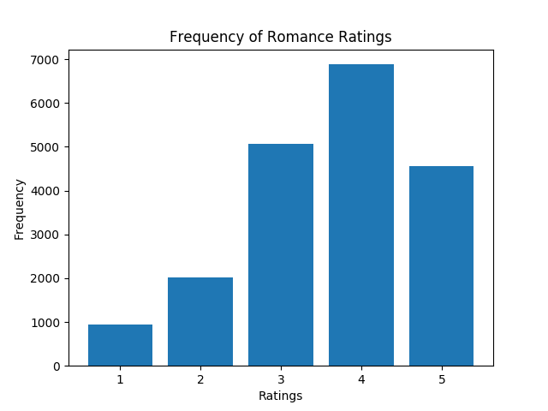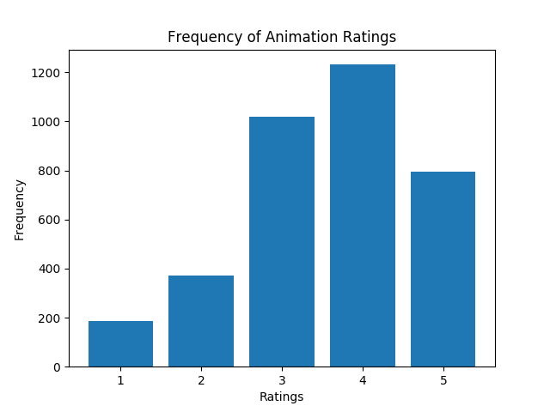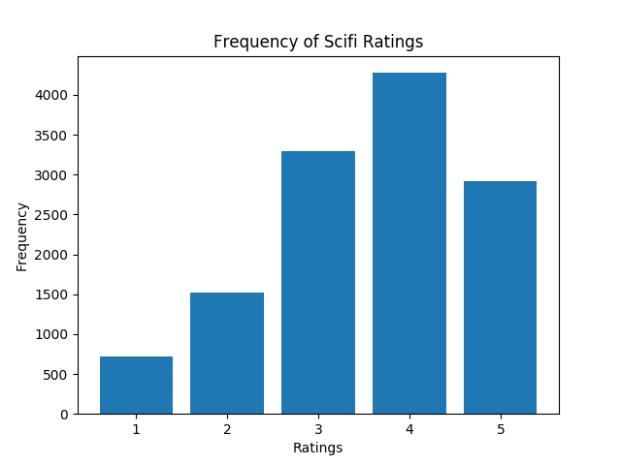

Figure : All ratings in the Animation, Romance, and Sci-Fi ratings.

**Matrix Factorization Methods**

***Theory***

*Model 1:*

Our initial method working by minimizing the expression by performing SGD with respect to U and V.

$${argmin}_{U,V}\frac{λ}{2}\left({\left|\left|U\right|\right|}_{F}^{2}+{\left|\left|V\right|\right|}_{F}^{2}\right)+\frac{1}{2}\sum_{i,j}{{\left(y_{ij}-{u_{i}}^{T}v_{j}\right)}^{2}}$$

This results in the decomposition of our original Y matrix consisting of M Users x N Movies into $U^{T}V$, where U is an M x k matrix and V is a N x k matrix.

*Model 2: Don’t know if we need something here.*

*Model 3:*

The off-the-shelf method from the surprise module works by minimizing the following expression by performing SGD:

$${argmin}_{q,p}{\sum_{u,i}{(r_{ui}-{\hat{r}}_{ui}})}^{2}+λ\left({\left|\left|q_{i}\right|\right|}^{2}+{\left|\left|p_{u}\right|\right|}^{2}\right)$$

Here:

$${\hat{r}}_{ui}={q_{i}}^{T}p_{u}$$

This is essentially the same as our model 1 approach. Here the r matrix consisting of M Users x N Movies will be decomposed into qTp, where q is an M x k matrix and p is a N x k matrix. We do notice here that the derivatives of the off-the-shelf method will be slightly different (multiplied by 2) from the homework 5 mode.

Similarly, the biased version of the off-the-shelf method works by having:

$${argmin}_{q,p}{\sum_{u,i}{(r_{ui}-{\hat{r}}_{ui}})}^{2}+λ\left({\left|\left|q_{i}\right|\right|}^{2}+{\left|\left|p_{u}\right|\right|}^{2}+{b_{i}}^{2}+{b_{u}}^{2}\right)$$

Here:

$${\hat{r}}_{ui}={q_{i}}^{T}p_{u}+b_{u}+b_{i}+μ$$

Here $μ$ is the mean of all ratings, while bi and bu are the user-specific and movie-specific deviation from global bias respectively.

***Implementation methods***

We chose the same stopping conditions as in homework 5. That is the SGD will stop if the loss reduction compared to the first epoch is less than 0.0001. This induced the SGD to stop after 30 epochs. We chose $λ=0.1,$ since this was observed to perform best in homework 5. Additionally, we chose the learning rate $η=0.03$. These parameters were chosen to be the same for both our own and our off-the-shelf implementation. However, there was no option to set any stopping conditions for the off-the-shelf implementation so we let the off-the-shelf implementation run for 30 epochs (effectively the same as our homework 5 model).

***Results***

Table 1 shows the RMSE accuracy of our 3 models.

|  |  |
| --- | --- |
| **Model type** | **RMSE** |
| Homework 5 model without bias | 0.7 |
| Homework 5 model with bias ? |  |
| Off-the-shelf model with bias | 0.9143 |
| Off-the-shelf model without bias | 0.9458 |

Hence, we can see that our homework 5 model performed best. Why? This would presumably be due to how the derivatives are computed and the way that the SGD is performed. We also observe, that the model with bias performs slightly better than the one without bias. This makes sense as we have extra parameters to ensure a more flexible fit to the data.

**Matrix Factorization Visualizations**

What, in general, did you observe? Did the results match what you would expect to see? How does the visualization of the most popular movies compare to that of the best movies? How do the visualizations of the three genres you chose compare to one another? How do the visualizations produced by the different matrix factorization methods compare to one another?